**Tous les liens des modules en ligne pour les découvrir !**

[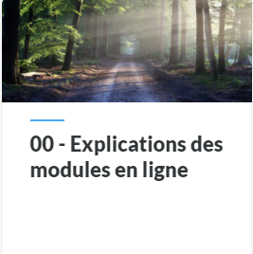](https://ressources-cep.ch/cours/CI_Modules/00_Explications_des_modules_en_ligne/#/) [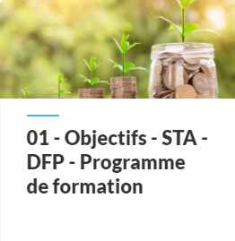](https://ressources-cep.ch/cours/CI_Modules/01_Objectifs_STA_DFP_Programme_de_formation/#/) [](https://ressources-cep.ch/cours/CI_Modules/02_08_Valeurs_comportement_bonnes_mani%C3%A8res_et_techniques_d_entretien/#/) [](https://ressources-cep.ch/cours/CI_Modules/03_Droits_d_information_protection_des_donn%C3%A9es_et_archivage/#/)

[](https://ressources-cep.ch/cours/CI_Modules/04_Organes_de_publication/#/) [](https://ressources-cep.ch/cours/CI_Modules/05a_Constitution/#/) [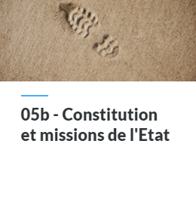](https://ressources-cep.ch/cours/CI_Modules/05b_Constitution/#/) [](https://ressources-cep.ch/cours/CI_Modules/05c_Constitution_R%C3%A9visions/#/)

[](https://ressources-cep.ch/cours/CI_Modules/06_Pr%C3%A9paration_%C3%A0_l_oral_de_l_unit%C3%A9_de_formation/#/) [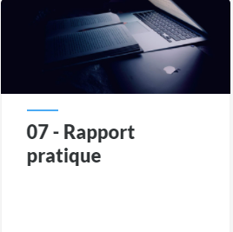](https://ressources-cep.ch/cours/CI_Modules/07_Rapport_pratique/#/) [](https://ressources-cep.ch/cours/CI_Modules/09a_Missions_de_l_entreprise/#/) [](https://ressources-cep.ch/cours/CI_Modules/09b_Missions_de_l_entreprise_Apprentis/#/)

[](https://ressources-cep.ch/cours/CI_Modules/09b_Missions_de_l_entreprise_Stagiaires_18_mois/#/) [](https://ressources-cep.ch/cours/CI_Modules/09c_Missions_de_l_entreprise_apprentis/#/) [](https://ressources-cep.ch/cours/CI_Modules/09d_Missions_de_l_entreprise_R%C3%A9visions/#/) [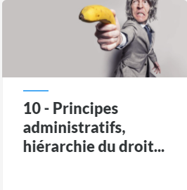](https://ressources-cep.ch/cours/CI_Modules/10_Hi%C3%A9rarchie_du_droit/#/)

[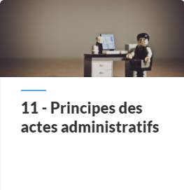](https://ressources-cep.ch/cours/CI_Modules/11_Principes_des_actes_administratifs/#/) **[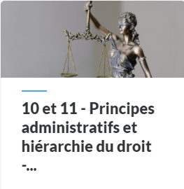](https://ressources-cep.ch/cours/CI_Modules/10_11_Principes_administratifs_et_hi%C3%A9rarchie_du_droit_r%C3%A9visions/#/)** [](https://ressources-cep.ch/cours/CI_Modules/12_March%C3%A9s_publics/#/) [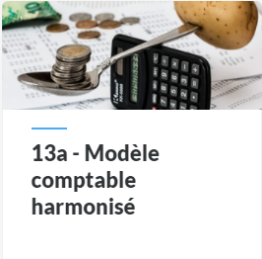](https://ressources-cep.ch/cours/CI_Modules/13a_MCH/#/)

[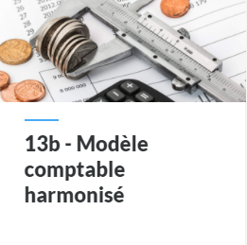](https://ressources-cep.ch/cours/CI_Modules/13b_MCH/#/) [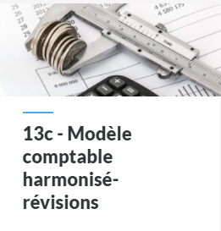](https://ressources-cep.ch/cours/CI_Modules/13c_MCH_R%C3%A9visions/#/) [](https://ressources-cep.ch/cours/CI_Modules/14_Redevances_et_taxes/#/) [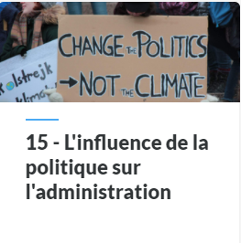](https://ressources-cep.ch/cours/CI_Modules/15_Influence_politique_administration/#/)

[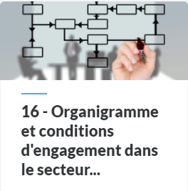](https://ressources-cep.ch/cours/CI_Modules/16_Organigramme_et_conditions_d_engagement/#/)[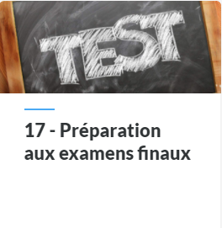](https://ressources-cep.ch/cours/CI_Modules/17_Pr%C3%A9paration_aux_examens_finaux/#/)